Perceptive Reach

Integrated Reach Database System

(IRDS)

Installation Guide



Department of Veterans Affairs

**September 2016**

**Version 2.0**

**Revision History**

|  |  |  |  |
| --- | --- | --- | --- |
| **Date** | **Version** | **Description** | **Author** |
| 9/12/2016 | 2.0 | Management Review | Matthew Robinson |
| 09/10/2016 | 1.9 | Added Custom Application Pool Instructions | Vasudha Upadhyaya |
| 09/09/2016 | 1.8 | Quality assurance review | Kaitlin Reskovac |
| 09/09/2016 | 1.7 | Reviewed and separated Application Server and Database Server Installation | Vasudha Upadhyaya |
| 9/8/2016 | 1.6 | Added database content | Bill Balshem |
| 8/17/2016 | 1.5 | Updated table content in section “6. Contact Information” | Kaitlin Reskovac |
| 5/25/2016 | 1.4 | Management Review | Matthew Robinson |
| 5/10/2016 | 1.3 | Updated the title page, page headers, and page footers to reflect the correct month. | Kaitlin Reskovac |
| 4/7/2016 | 1.2 | Updated title page, page headers, and page footers to reflect the correct month. | Kaitlin Reskovac |
| 3/8/2015 | 1.1 | Added Facility Surveillance backend processing items | Bill Balshem |
| 9/14/2015 | 1.0 | Final Review | Paul Bradley/Monica Mohler |
| 9/12/2015 | 0.6 | Contract Compliance and Quality Assurance Review | Matt Robinson/Kaitlin Reskovac |
| 9/12/2015 | 0.5 | Various document Updates | Andrew Smith/Robert Snelling/Matt Robinson/Kaitlin Reskovac |
| 9/11/2015 | 0.4 | Document Updates | Robert Snelling |
| 9/09/2015 | 0.3 | Document Updates | Matthew Robinson |
| 8/31/2015 | 0.2 | Document Review | Andrew Smith |
| 8/25/2015 | 0.2 | Document Review | Andrew Smith |
| 8/24/2015 | 0.2 | Document Review | Andrew Smith |
| 6/17/2015 | 0.2 | Document Review | Paul Bradley/Andrew Smith |
| 6/05/2015 | 0.2 | Document Review | Paul Bradley |
| 6/04/2015 | 0.2 | Document Review | Paul Bradley |
| 6/02/2015 | 0.1 | Initial Version | Matt Robinson/Radina Ivanova |

**Table of Contents**

1. About This Document 3

2. Introduction 3

2.1. Purpose 3

2.2. Scope 3

2.3. Software 3

3. Installation Manual 4

3.1. Pre- requisites 4

3.1.1. Database Server 4

3.1.2. Web Application Server 5

3.2. Pre-installation Tasks 5

3.3. Database Installation Procedure 5

3.3.1. Database 5

3.3.1.1. Reach Database Installation 5

3.4. Web Application Server Installation 6

3.4.1. R/R Studio 6

3.4.2. Additional R Libraries 6

3.4.3. Facility Surveillance GitHub Code 7

3.4.4. Analytics Applications 7

3.4.5. Web Application 37

3.4.6. Web Application Configuration 61

3.4.6.1. Configure IIS Site 61

4. Post-Installation 65

4.1. Technical Tests 65

5. Uninstall 65

6. Acronyms 65

# About This Document

This document is a “work in progress.” In accordance with industry-standard Agile best practices, this document will be populated with content as the design of the application’s architecture evolves with each sprint. As development continues, any activity that requires a change in the installation procedure for the application and related components will require a subsequent update to this document.

# Introduction

This guide is developed for the Perceptive Reach Integrated Reach Database System (IRDS) project for the Department of Veterans Affairs (VA). VA is seeking to expand suicide prevention to include upstream approaches designed to reduce initiation or escalation of a suicide risk factor. Upstream suicide interventions target individuals or groups who exhibit biological, psychological, or social risk factors that are more prominent among high-risk groups than among the larger population. Understanding the unique needs of our nation’s Veterans and the military culture as it relates to stigma and mental health is important for early intervention. The goal of the IRDS innovation is to promote the general health of the Veteran population and effectively intervene in issues before they escalate into crisis.

The IRDS solution will harness the power of large and diverse data stores to aggregate, analyze and identify risk onset as well as reveal previously unidentified at-risk individuals and populations as a holistic and integrated approach. The IRDS innovation will serve to bolster the three major components of Veterans Health Administration’s (VHA) Strategic Plan for Suicide Prevention: surveillance, risk and protective factors, and prevention interventions. The IRDS innovation will target antecedent events specific to Veteran populations prior to the onset of risk to mitigate the development of risk.

## Purpose

The purpose of this installation guide is to provide instructions for use by the technical staff who will install the Integrated Reach Database System which consists of a two server setup, database server and web application server.

## Scope

The document is intended for system administrator level technical staff with knowledge and experience in database and application installation and configuration.

## Software

Table : Software Components

|  |  |
| --- | --- |
| Technology | Technical Reference Model (TRM) Status |
| RStudio | Approved w/Constraints [1] |
| R for Statistical Computing | Approved w/Constraints [3] |
| MS SQL Server | Approved w/Constraints [1] |
| SQL Server Management Studio | Approved w/Constraints [1] |
| Jenkins | Approved |
| Cucumber | Approved w/Constraints [1] |
| Jasmine | Approved |
| Internet Information Services (IIS) | Approved w/Constraints [1] |
| IIS for NODE | Requested (Assigned) - 4/15/2015 |
| Adobe Brackets | Approved w/Constraints [1] |
| Node.js (v0.10.35) | Approved w/Constraints [1] |
| Express.js | Approved w/Constraints [1] |
| Angular.js | Approved |
| jQuery | Approved w/Constraints [1] |
| Bootstrap | Approved |
| Bower | Approved w/Constraints [1] |
| Grunt | Approved w/Constraints [1] |
| Gulp | Approved w/Constraints [1] |
| Karma | Requested (Assigned) - 4/28/2015 |
| SourceTree | Requested (Assigned) - 4/4/2013 |
| Internet Explorer 11 | Approved w/Constraints [1] |
| jQuery UI | Requested (Assigned) - 4/15/2015 |
| malhar-angular-widgets | Unknown |
| malhar-angular-dashboard | Unknown |
| Gridster.js | Unknown |
| Angularjs-nvd3-directives | Unknown |
| NVD3.js | Unknown |
| d3.js | Approved w/Constraints [1] |
| node-mssql | Unknown |
| msnodesql | Unknown |

# Installation Manual

## Pre- requisites

The entire installation process requires administrator authority. The database and web application server require separate instances of the operating system and associated software listed below. The administrator installing the software must be able to access the internet.

### Database Server

* Windows Server 2012 x64
* SQL Server 2012 Enterprise Edition

### Web Application Server

* Windows Server 2012 x64
* IIS 8.x with IIS Management Tools and ASP.NET

## Pre-installation Tasks

* Access to the internet
* Any web filters, browser configurations, or network restrictions must be mitigated to facilitate the download of software from the internet.

## Database Installation Procedure

### Database

In order to make the process more efficient and consistent, the installation of the database will be based on restoring the most recent backup from GitHub.

### Reach Database Installation

1. Download the latest database backup from GitHub (<https://github.com/VHAINNOVATIONS/PerceptiveReach/tree/dev/Database>) to the database backup folder (E:\DBBackups\UserDB) of the IRDS database server. The latest compressed backup (.bak) of the Reach Database from the IRDS development server will be checked into the Perceptive Reach GitHub repository. You can identify the latest backup through the file naming convention. The date of the backup is in the filename (ex: Reach_Dev_Jun_14_2015.bak).

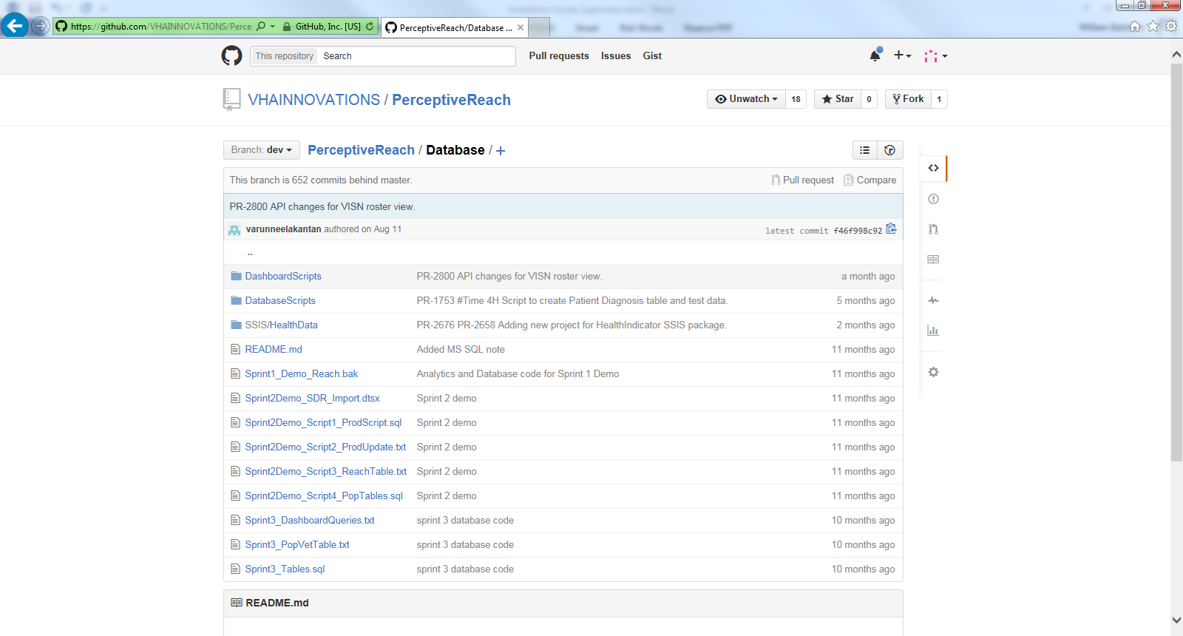

1. On the IRDS database server, retrieve the Reach database backup file from the Perceptive Reach GitHub repository, and place it in the E:\DBBackups\UserDB folder.
2. On the IRDS Server open SQL Server Management Studio (SSMS), open a New Query page and run the following script:

USE MASTER

GO

RESTORE DATABASE Reach FROM DISK = 'E:\DBBackups\UserDB\Reach_Dev_Jun_15_2015.bak' WITH RECOVERY,

MOVE 'Reach' to 'E:\SQLData\Reach.mdf',

MOVE 'Reach_log' to 'L:\SQLLogs\Reach_log.ldf'

NOTE: replace 'Reach_Dev_Jun_15_2015' with the actual file name of the Reach database backup file

1. Encrypt the database.

AITC supplied the encryption certificate for the IRDS database server and installed it on the machine. To encrypt the database, in SSMS run the command below to encrypt the production database against that certificate.

**USE <database name>;**

**GO**

**CREATE DATABASE ENCRYPTION KEY**

**WITH ALGORITHM = AES_128**

**ENCRYPTION BY SERVER CERTIFICATE <cert name>;**

**GO**

**ALTER DATABASE <database name>**

**SET ENCRYPTION ON;**

**GO**

For steps on how to load data into the database (running SSIS imports, executing stored procedures) see the Perceptive Reach Developers Guide and the System Administration Guide.

## Web Application Server Installation

### R/R Studio

The Attempt Prediction Chart Widget needs R to be installed on the database server. To install R/R Studio on the database server, follow the same instruction for R/R Studio installation on the IRDS web application server in the analytics section of this document.

### Additional R Libraries

The R programs developed for Facility Surveillance analysis, as described in the section above, call for the installation of additional R libraries. Once R/R Studio are installed on the IRDS database server, Open the R console and type the following commands:

> install.packages("plyr", lib="C:/Program Files/R/R-3.2.2/library")   
> install.packages("sandwich", lib="C:/Program Files/R/R-3.2.2/library")

NOTE: when running commands above “R-3.2.2” should be replaced with whatever version of R has been installed on the server.

### Facility Surveillance GitHub Code

On the IRDS database server, login to GitHub via a web browser and select VHAINNOVATIONS/PerceptiveReach repository. Select the stable branch and click the “Download Zip” button. Verify that the file PerceptiveReach-stable.zip has been downloaded to the server.

Either Create the Folder C:\IRDS or verify that it already exists on the server. Place the PerceptiveReach-stable.zip in the C:\IRDS folder and extract.

### Analytics Applications

Follow the steps below to install the Analytics applications. The Analytics applications will reside on the IRDS Web Application Server. To gain access to the Analytic tools a user must contact the system owner or approving body for procedures necessary to obtain a User Account and a VA Strong Authentication eToken.

1. Install R v3.2.x ([http://www.va.gov/TRM/ToolPage.asp?tid=6117#](http://www.va.gov/TRM/ToolPage.asp?tid=6117))

R is an open source data analytics tools widely used in the statistical community for all types of statistical analysis.

Download the approved version of R -

https://cran.r-project.org/bin/windows/base/old/3.2.2/

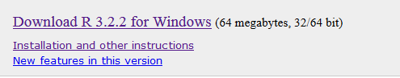

1. **Follow the default prompts for the installation.**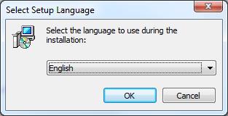

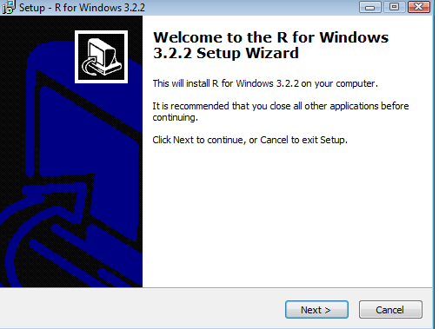

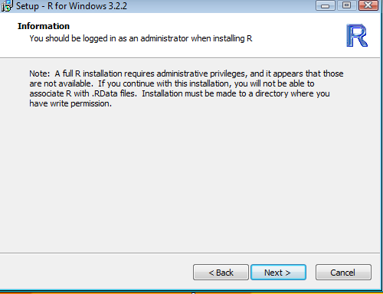

1. 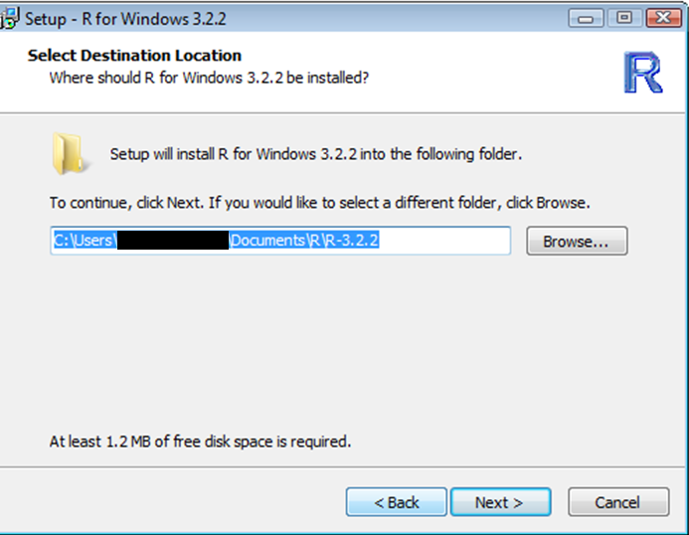
2. 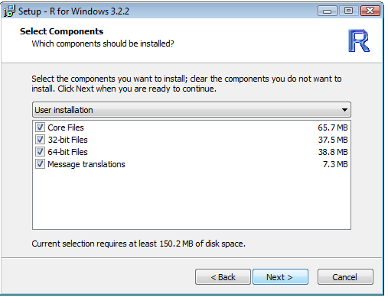
3. 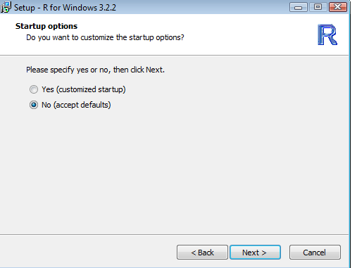
4. 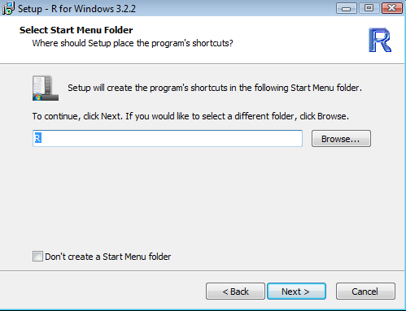
5. 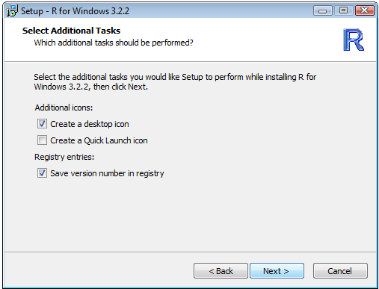
6. 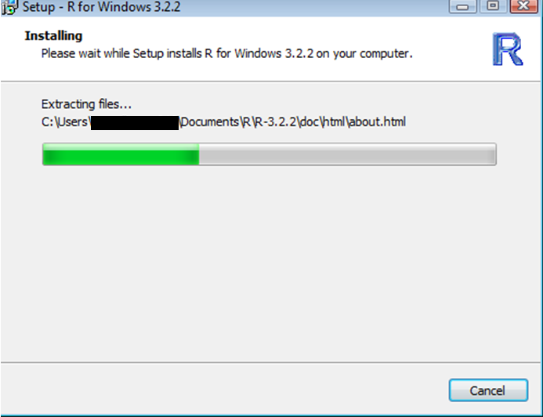
7. 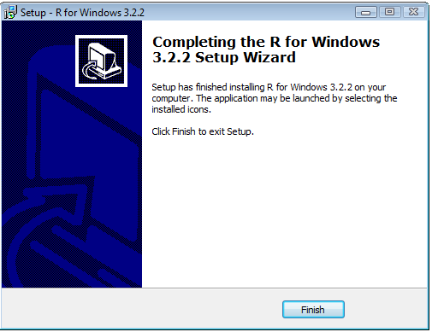
8. **Install RStudio Desktop**

RStudio Desktop is an open source Integrated Development Environment (IDE) for R that is commonly used by R programmers.

1. Download the latest version of RStudio. - <http://download1.rstudio.org/RStudio-0.98.1103.exe> VA TRM (<http://www.va.gov/TRM/ToolPage.asp?tid=6656>)
2. Follow the default prompts for the installation.
3. 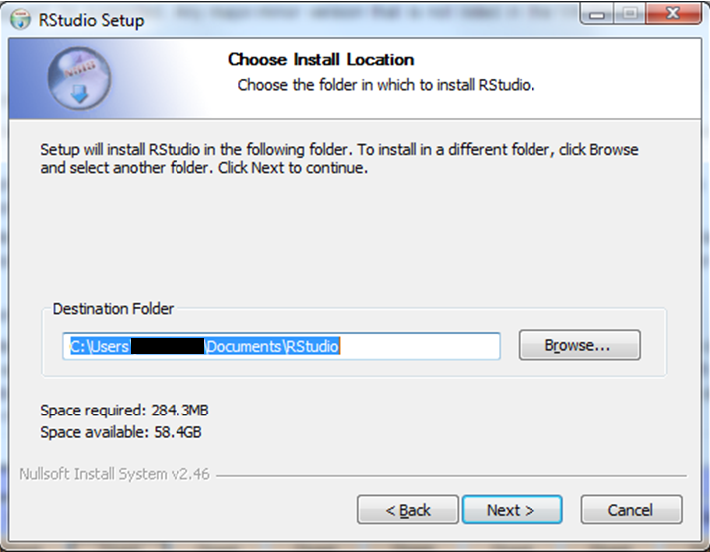
4. 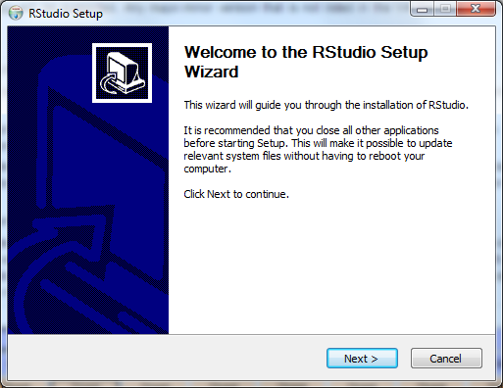
5. Enter the Destination Folder where applications are installed example C:/Program Files/RStudio
6. 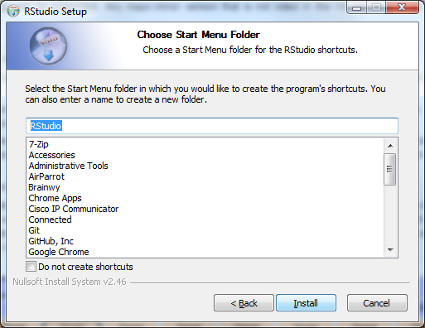
7. 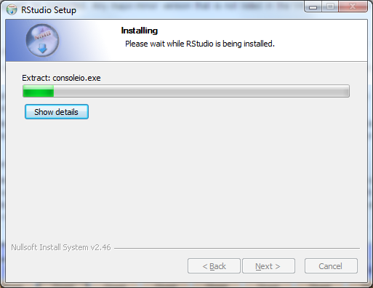
8. 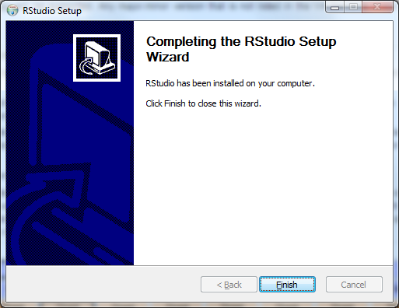
9. Start R Studio Desktop
10. From within R Studio Navigate to the “Packages” sidebar.
11. 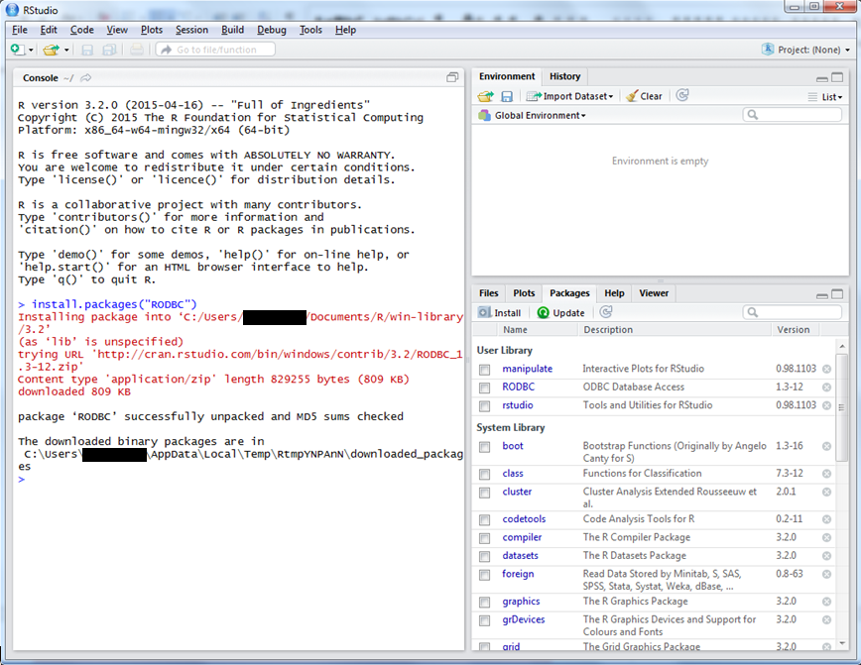
12. Click the “Install” button, enter RODBC in the search field, and then press the “Install” button. At this point R Studio will start a process to search the CRAN repository for the RODBC package, download it, validate it and install it.
13. Select”RODBC” in the Packages Panel and verify that is loaded in the Console window.
14. 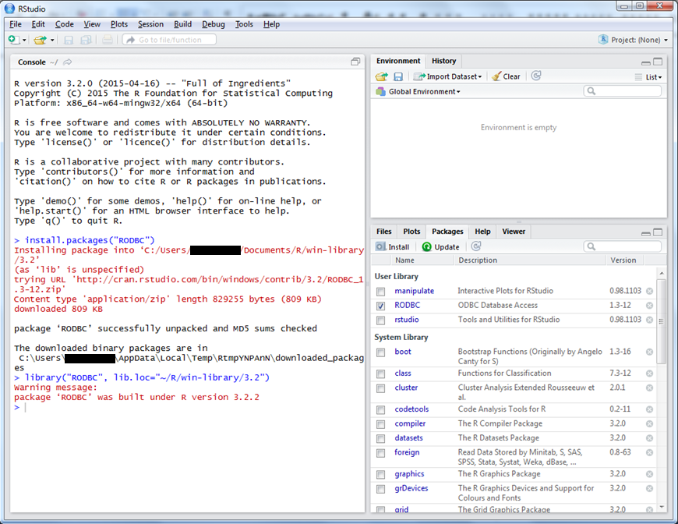
15. Install Business Intelligence Reporting Tool (BIRT) (<https://www.eclipse.org/downloads/packages/eclipse-ide-java-and-report-developers/lunasr2>) –Version v4.4.2 VA TRM ([http://www.va.gov/TRM/ToolPage.asp?tid=1346#](http://www.va.gov/TRM/ToolPage.asp?tid=1346))

An open source technology platform used to create data visualizations and reports that can be embedded into rich client and web applications.

1. **BIRT requires the installation of a Java JDK. Download the jdk-7u76-windows-i586 (**<http://www.oracle.com/technetwork/java/javase/downloads/java-archive-downloads-javase7-521261.html#jdk-7u76-oth-JPR>**) VA TRM (**[http://www.va.gov/TRM/ToolPage.asp?tid=5161#](http://www.va.gov/TRM/ToolPage.asp?tid=5161)**)** 
   1. 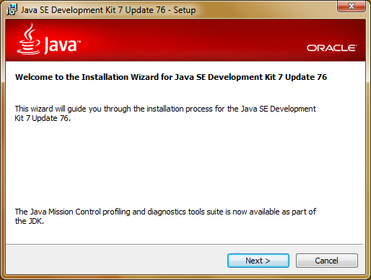
   2. 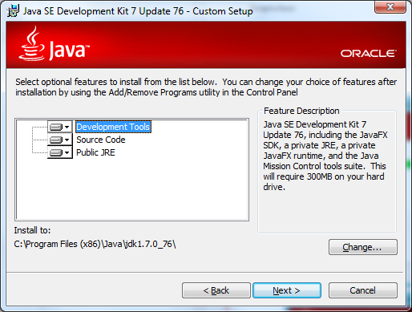
   3. 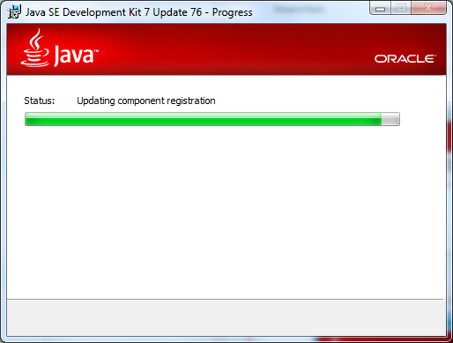
   4. 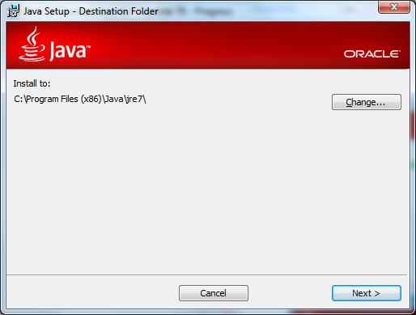
   5. 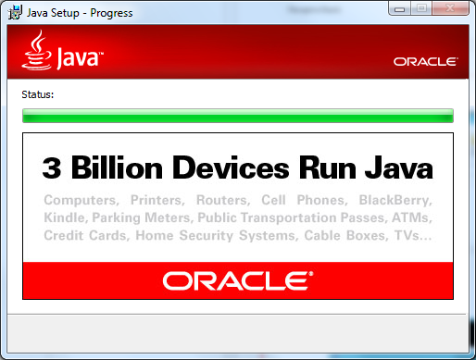
   6. 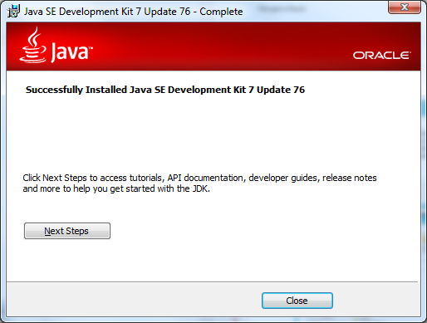
   7. **BIRT requires the addition of the JDK to the system Environment Variable PATH**
   8. **Access the Control Panel\System and Security\System**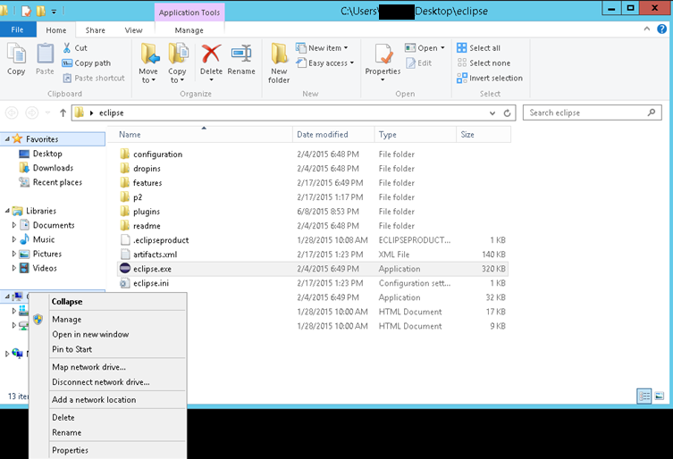
   9. **Select “Advanced system settings”** 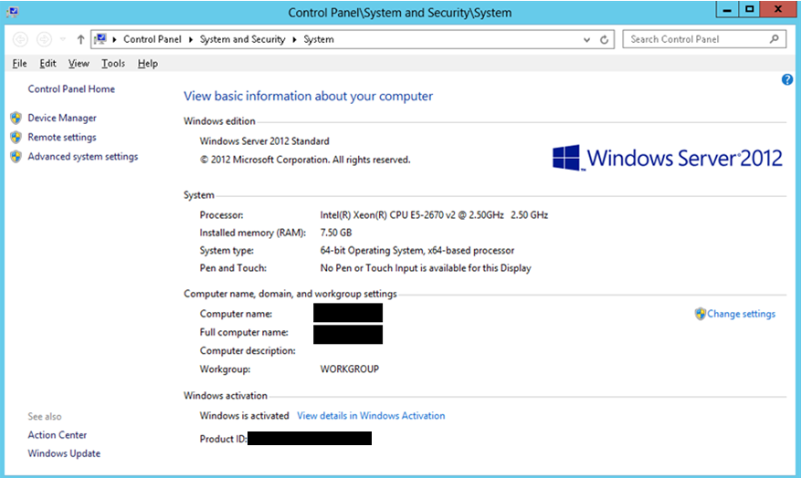
   10. **Select “Environment Variables”**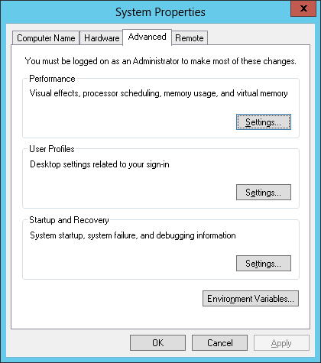
   11. **Select “Path” in the “System variables” section**

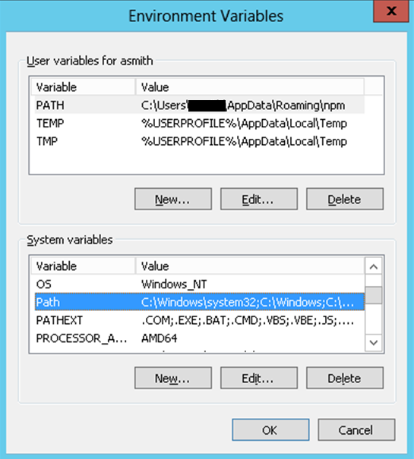

* 1. **Add the following to the end of the PATH variable “;C:\** **Program Files (x86)\Java\jre7\bin\” – Path requires a “;” semi-colon between each entry**
  2. 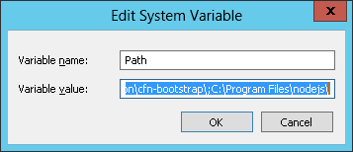

1. Download the BIRT ZIP package at (<http://www.eclipse.org/downloads/download.php?file=/birt/downloads/drops/R-R1-4_4_2-201502171805/birt-report-designer-all-in-one-4_4_2-20150217.zip>)
2. Select the Download link and save the ZIP file of BIRT to an appropriate temporary location.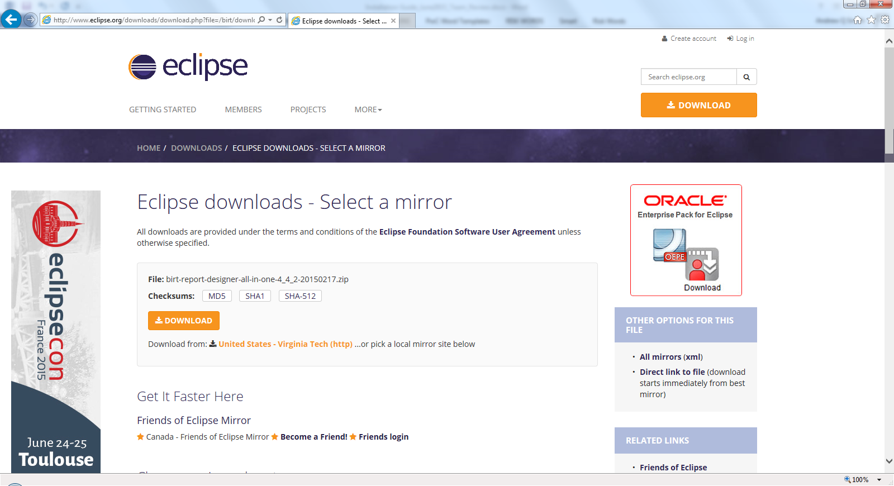
3. **Open the BIRT-*.zip file with WinZip or similar tool** 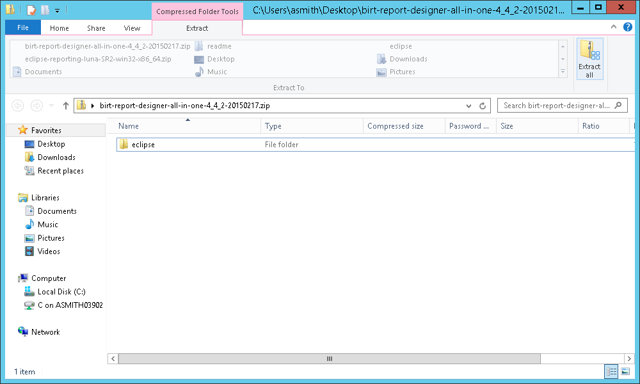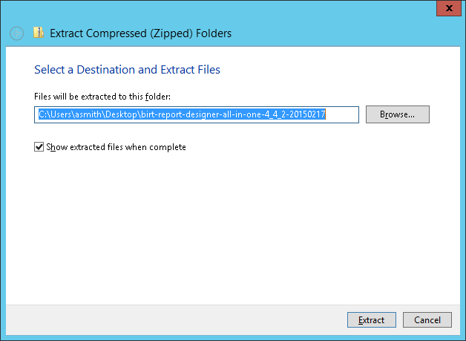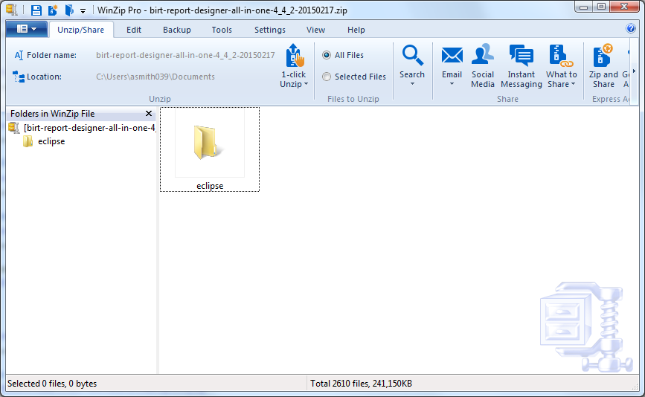
4. **Extract the file to the location where applications are installed example C:/Program Files/BIRT**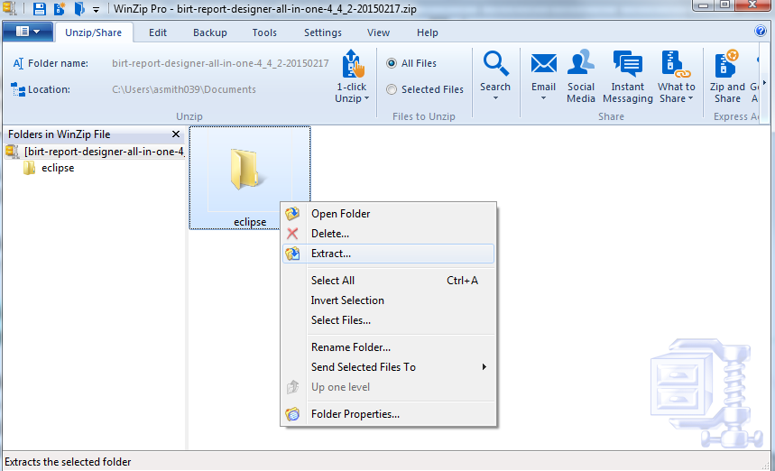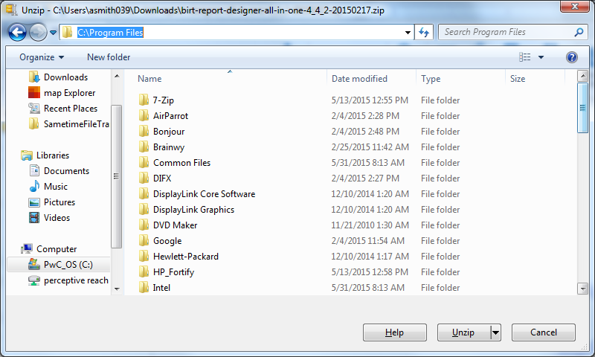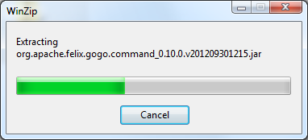
5. **Navigate to the Desktop to Create a Windows Shortcut**
6. **From the desktop, right click, choose New -> Shortcut.**
7. **For location, enter "C:\Program Files\BIRT\eclipse.exe" (without quotes.)**
8. **Click Next**
9. **Enter "BIRT" for the shortcut name.**
10. **BIRT requires a Java Database Connectivity (JDBC) drive to connect to the database**
    1. Download the Microsoft JDBC Drivers 4.1 for SQL Server from <http://msdn.microsoft.com/en-us/sqlserver/aa937724> -> sqljdbc_4.1.5605.100_enu.exe
    2. Run sqljdbc_4.1.5605.100_enu.exe
    3. Unzip the file(s) in %ProgramFiles% with the default directory: "Microsoft JDBC Driver 4.x for SQL Server".
    4. Open BIRT to configure the JDBC Driver
    5. **Open a BIRT report design, go to the Data Explorer view, right click on "Data Sources" and select "New Data Source". Choose "JDBC Data Source" and click "Next". In the next dialog, choose "Manage Drivers..." to bring up the "Manage JDBC Drivers" dialog. In the "JAR Files" tab, click on "Add..." to add the JAR file required by the JDBC driver. Then go to the "Driver" tab to confirm that the list of drivers includes the new drivers added. If desired, assign a display name and Uniform Resource Locator (URL) template for the new drivers in this tab.**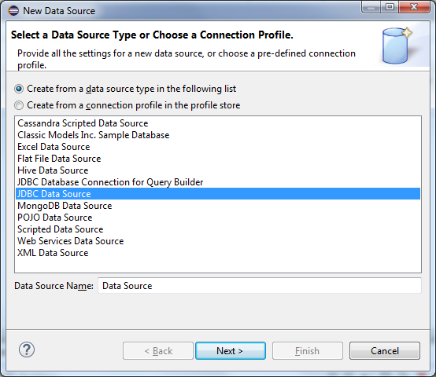 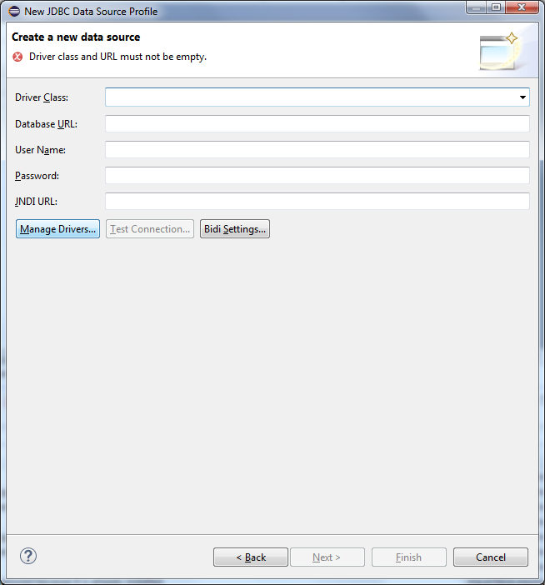 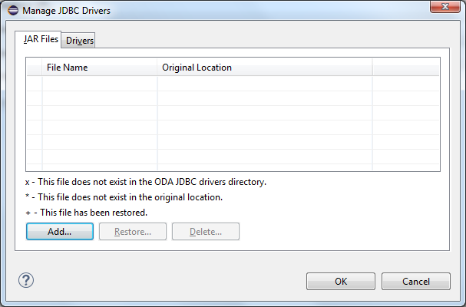 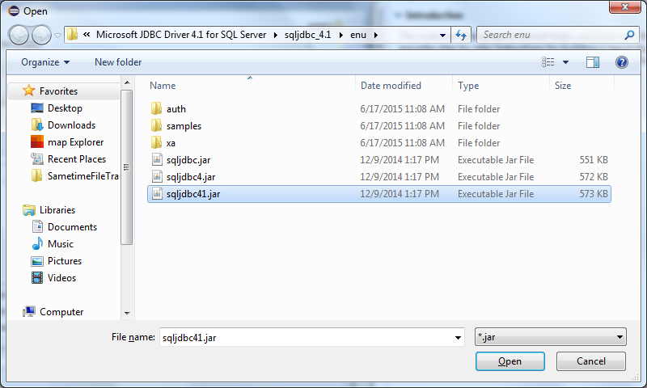 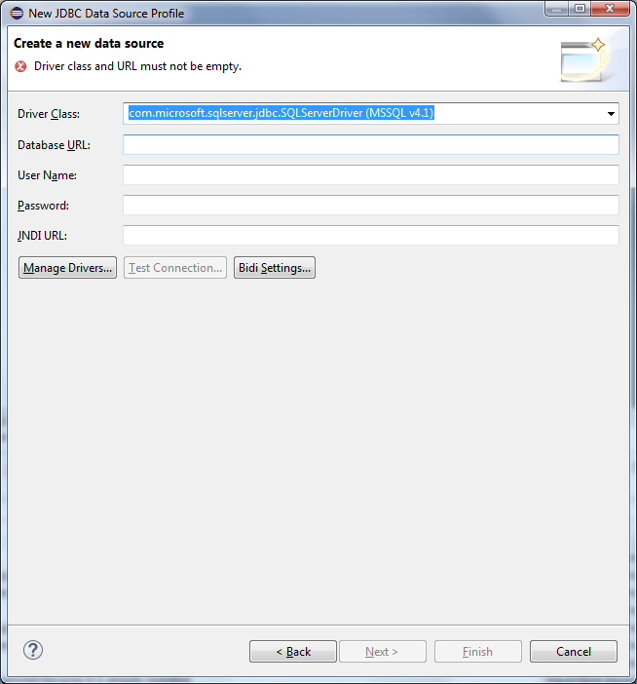
    6. **With the driver added configure the SQL server connection information. Database URL: Username: Password:**
11. **Install Microsoft SQL Server Management Studio (SSMS). (link) v.** - SSMS will be used on the Web Application Server by Research staff to view data and generate reports.**
    1. **Step 1 - Install the software**
    2. 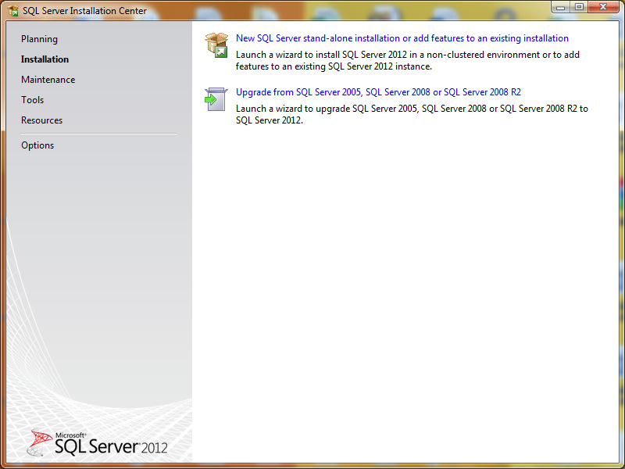
    3. 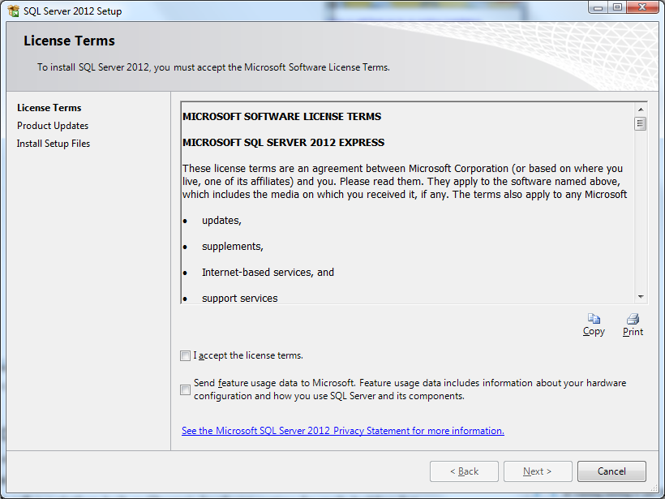
    4. 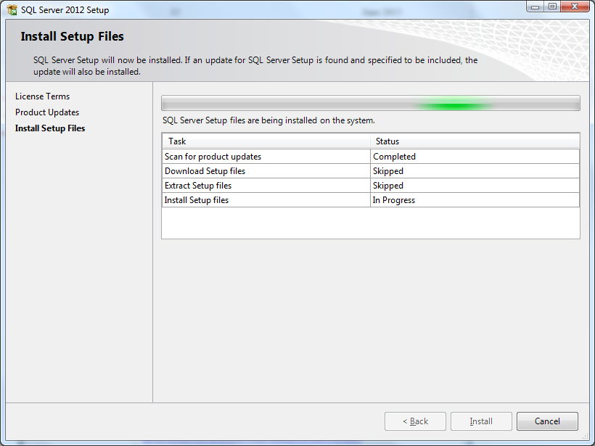
    5. 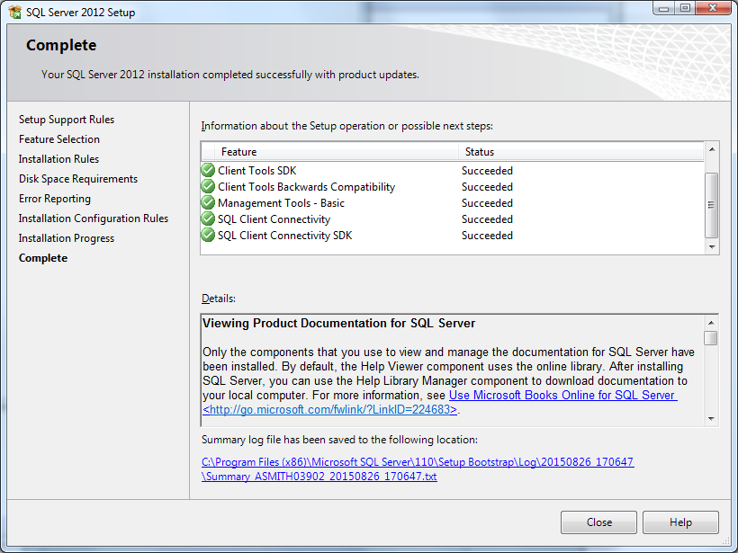
    6. 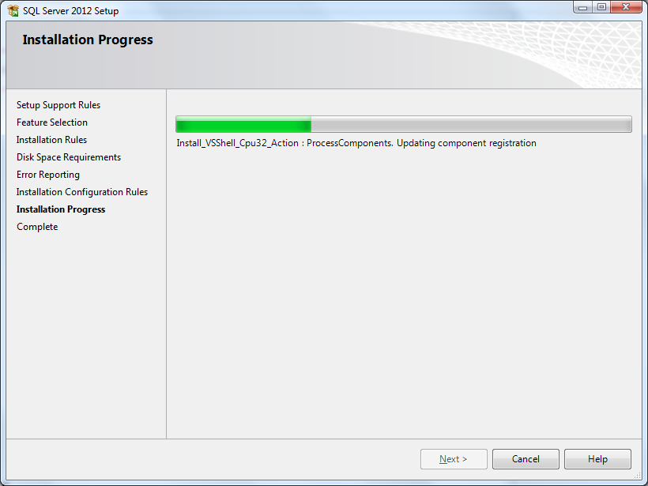
    7. 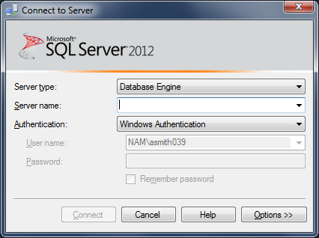

### Web Application

Follow the steps below to install the Dashboard and Direct applications.

1. **Install Node.js Version 0.12.4– (**<http://www.va.gov/TRM/ToolPage.asp?tid=6716>**)**

**Node.js® is a platform built on Chrome's JavaScript runtime for easily building fast, scalable network applications. Node.js uses an event-driven, non-blocking I/O model that makes it lightweight and efficient, perfect for data-intensive real-time applications that run across distributed devices.**

1. **Download the 0.12.4 version of node.js. – (**<http://nodejs.org/dist/v0.12.4/x64/node-v0.12.4-x64.msi>**)**
2. **Follow the default prompts for the installation.**

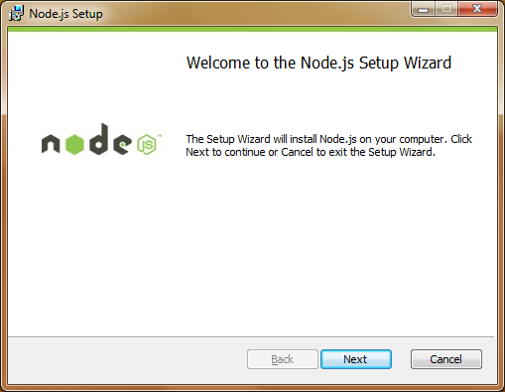

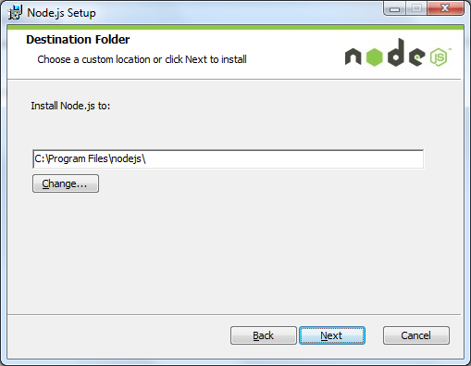 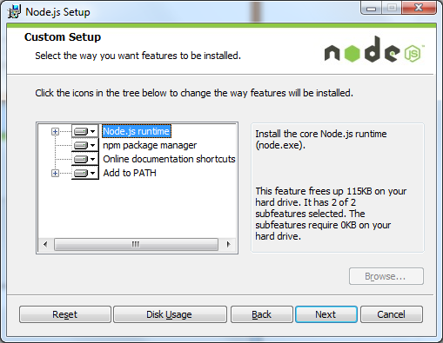 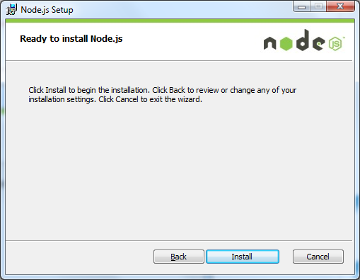

1. **Install IIS and modules**
   1. Install IIS via the “Turn Windows features on or off” functionally and prompts.
   2. Access “Server Manager”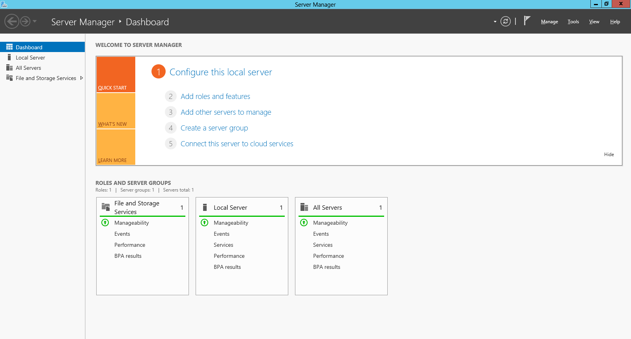
   3. Select “Add roles and features”
   4. 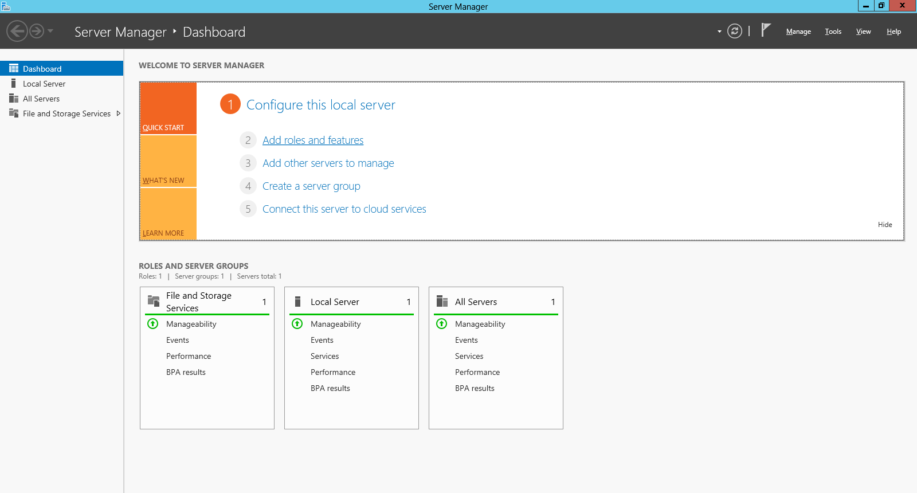
   5. 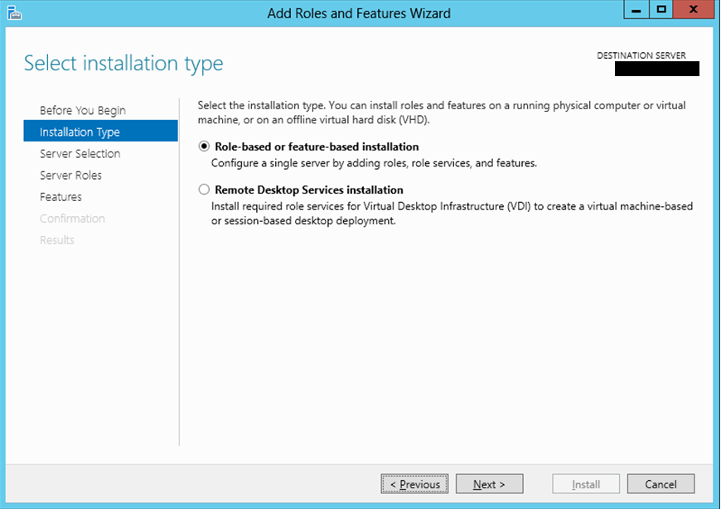
   6. Select the server for the IIS installation

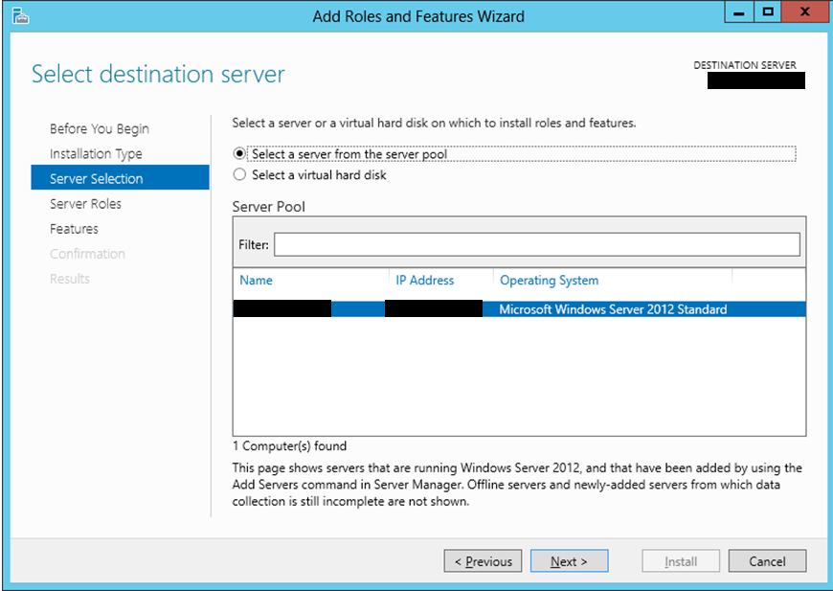

* 1. Select Web Server (IIS)
  2. 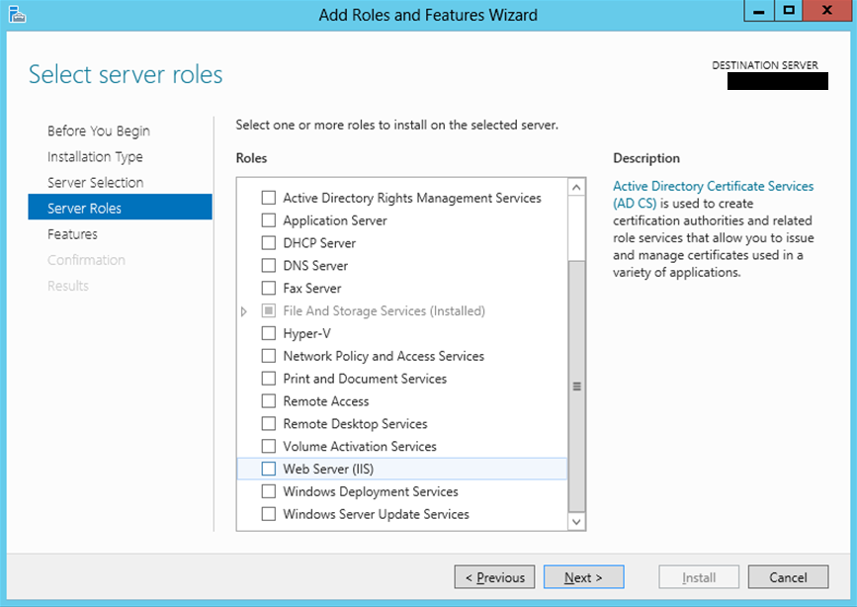
  3. Select “Add Features”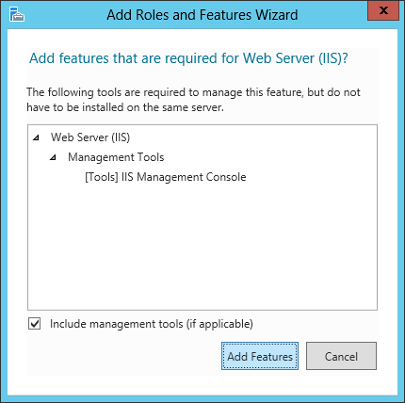
  4. 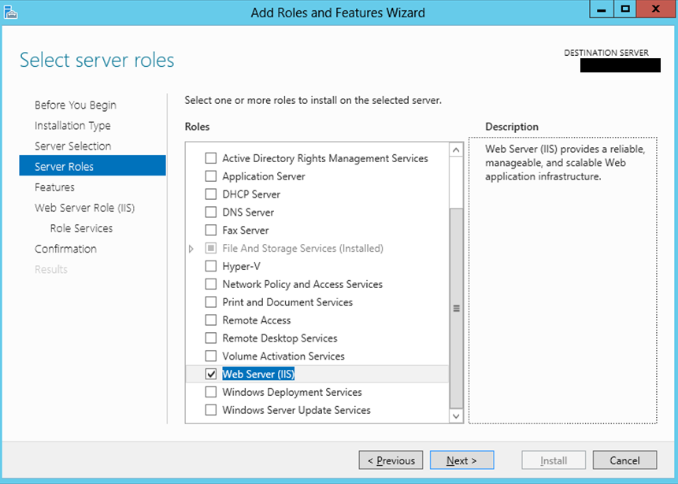
  5. After enabling IIS select next and move on to adding additional Features

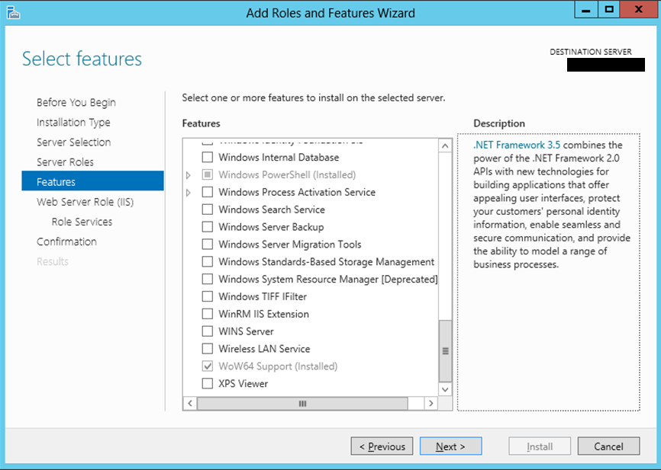

* 1. 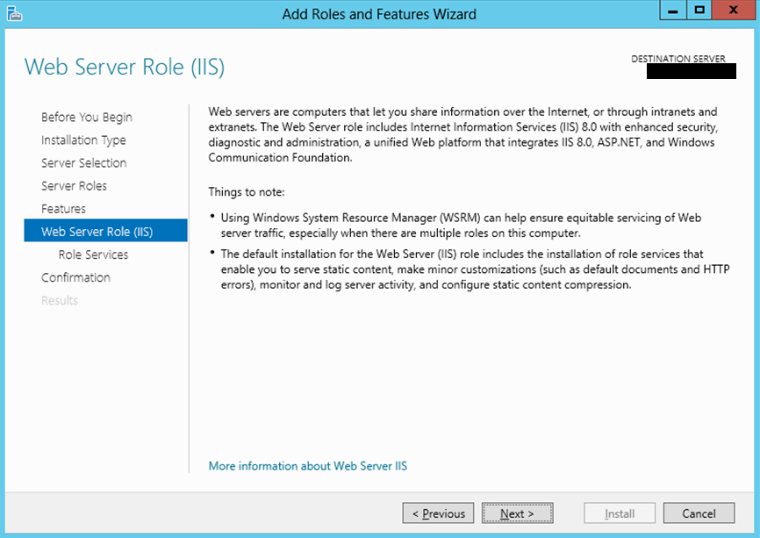
  2. Enable “Application Development” -> “.Net Extensibility 4.5”

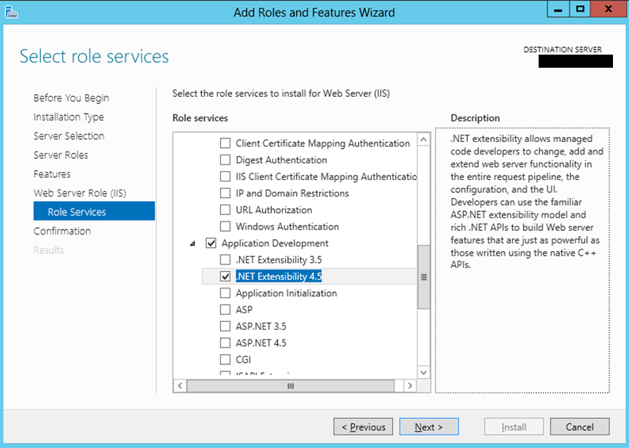

* 1. Select “Add Features” 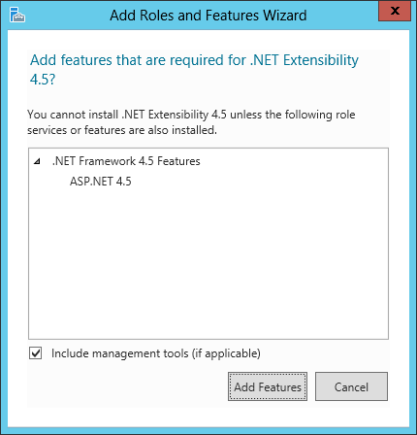
  2. Select “Application Development” -> “ASP.NET 4.5”

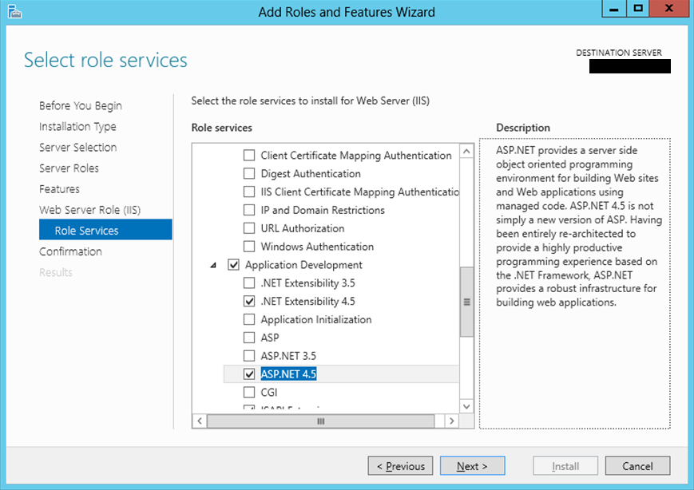

* 1. Select “Add Features”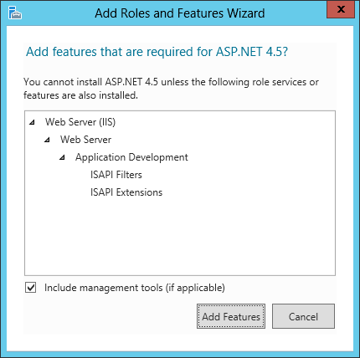
  2. Select “Application Development” -> “ASP.NET 4.5” 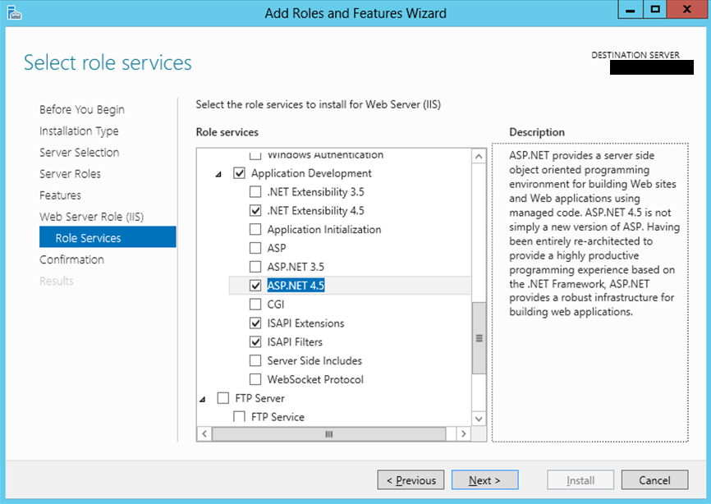
     1. Make sure to enable the following features in addition to those enable by default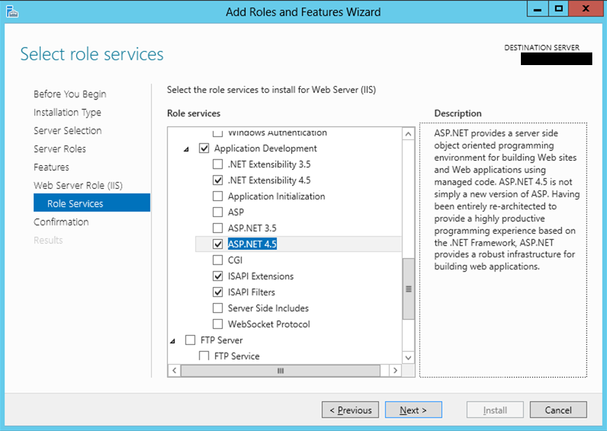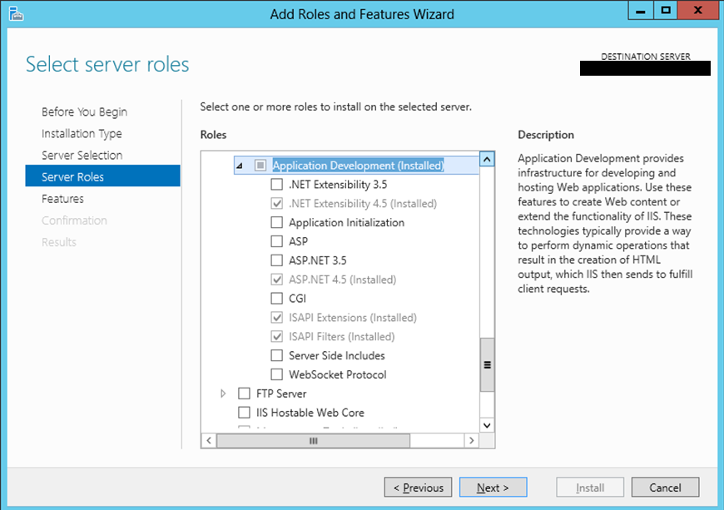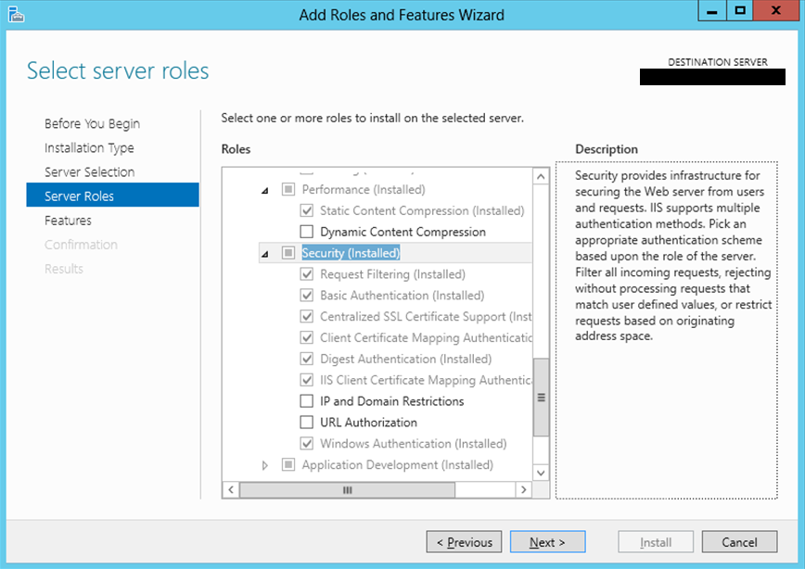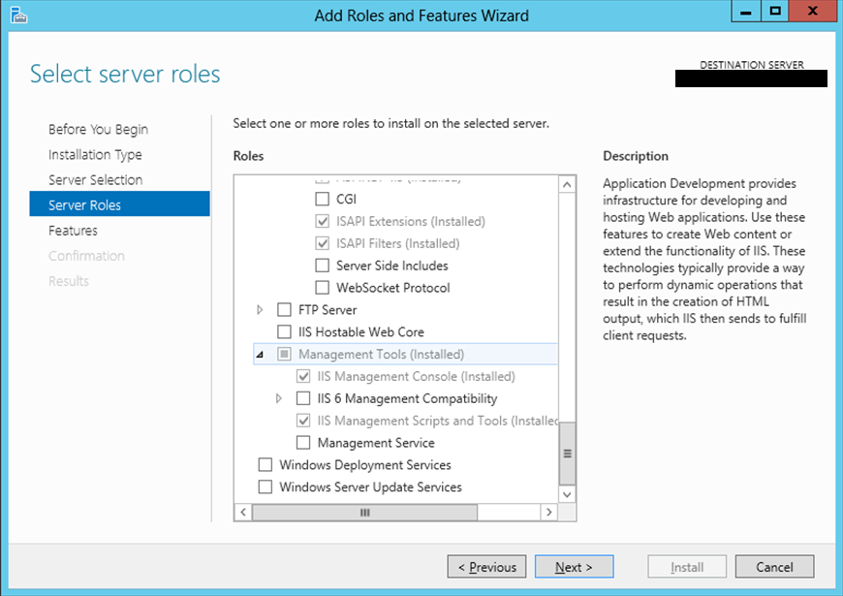

1. After checking the boxes and clicking Next an installation screen should appear. 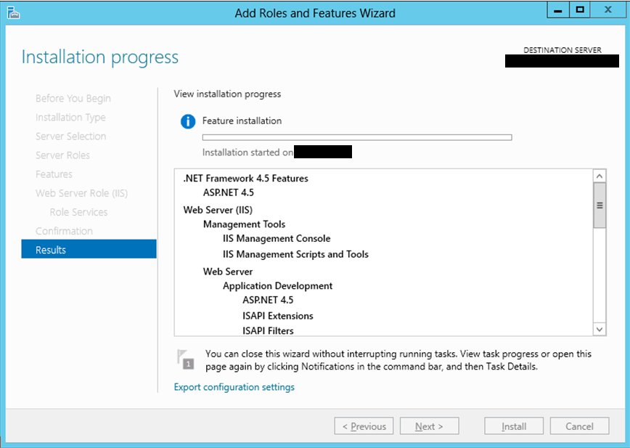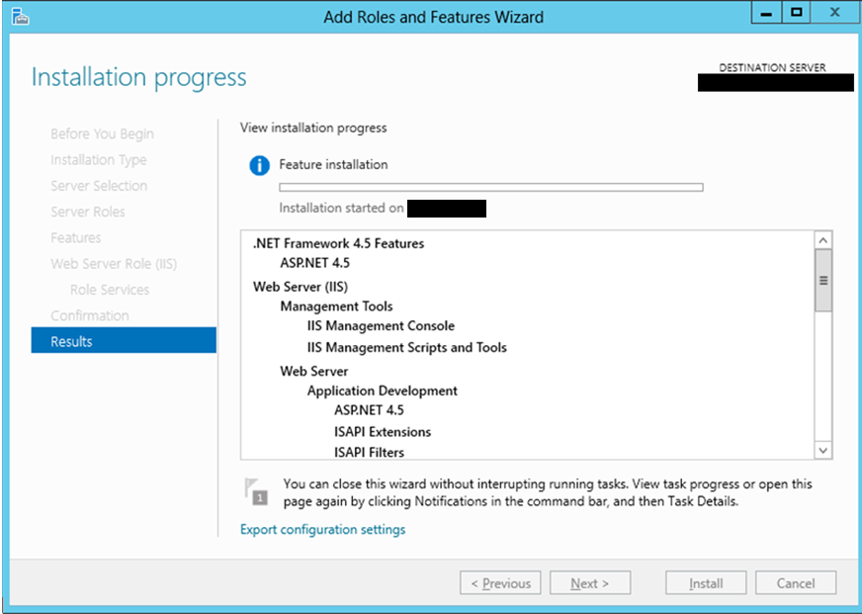

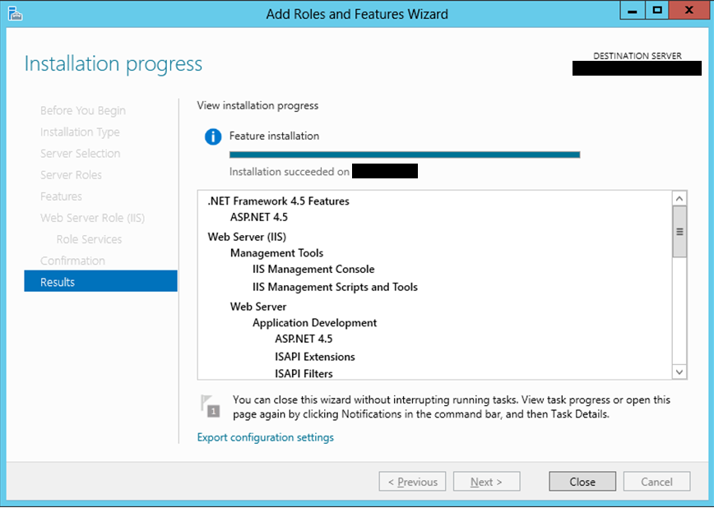

* 1. Install the IIS URL ReWrite Module - <http://www.iis.net/downloads/microsoft/url-rewrite>

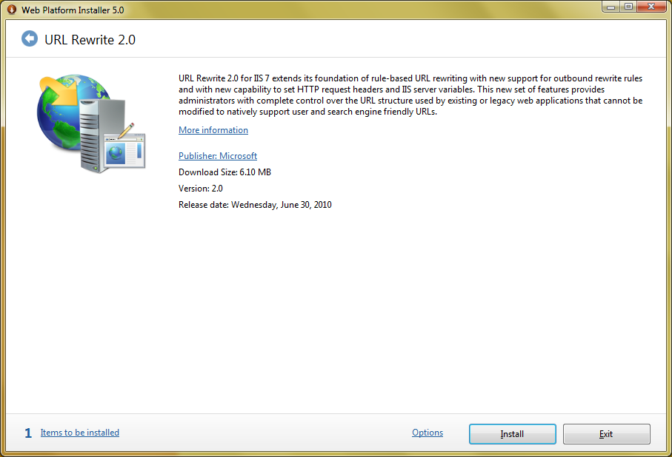

* 1. **Download version 0.2.17 “full” version of iisnode at** <https://github.com/azure/iisnode/releases/>

**Note: Choose x64 bit for the web application server**

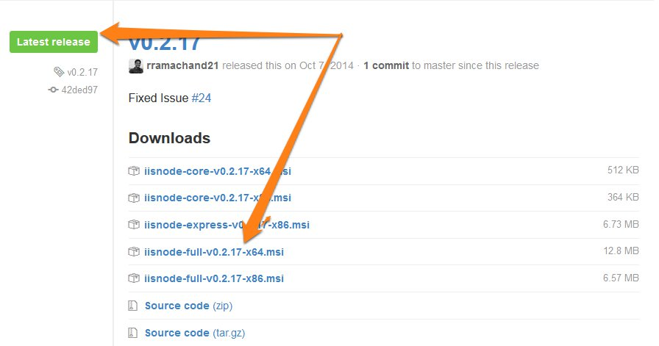

* 1. **Follow the default prompts for the installation.**

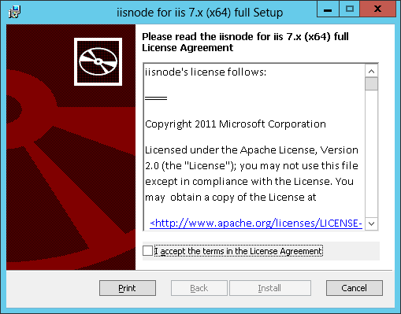

1. **Follow instructions to build the Perceptive Reach release package under Developers Guide Section 8.**
   1. Unzip the release packages in their respective directory.

**Dashboard:**

* + 1. After the file transfer is complete go to the D:\PerceptiveReach\Dashboard on the web application server
    2. Right click on the Dashboard release zip file and select “Extract All…”
    3. In the prompt make sure the extracted to folder is D:\PerceptiveReach\Dashboard.
    4. Select “Extract”

**Direct:**

1. After the file transfer is complete go to the D:\PerceptiveReach\Direct on the web application server
2. Right click on the Direct release zip file and select “Extract All…”
3. In the prompt make sure the extracted to folder is D:\PerceptiveReach\Direct.
4. Select “Extract”
   1. **Steps to configure applications**

**Dashboard**

* + 1. **Modify the .env file as needed.**

**Direct**

1. **Modify the .env file as needed.**

### Web Application Configuration

### Configure IIS Site

* 1. Access the Internet Information Services (IIS) Manager via the Start Menu
  2. 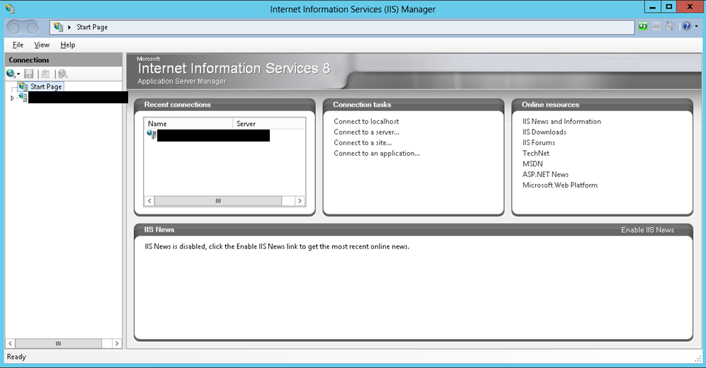
  3. Stop the “Default Web Site” 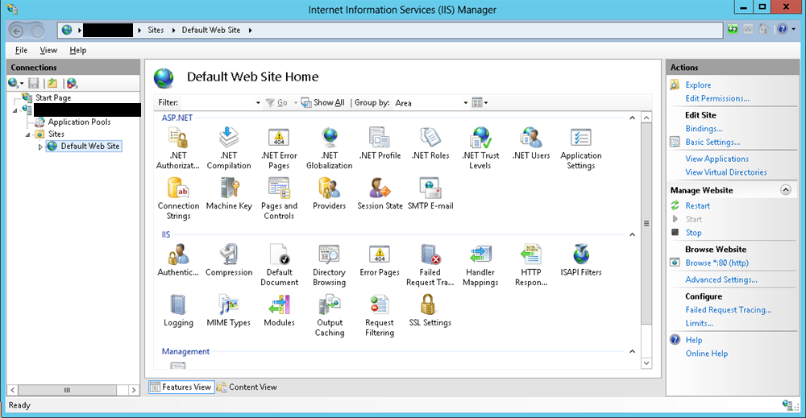
  4. Using the “Add Website” function accessed by right clicking on “Sites” – Proceed to create the Perceptive Reach site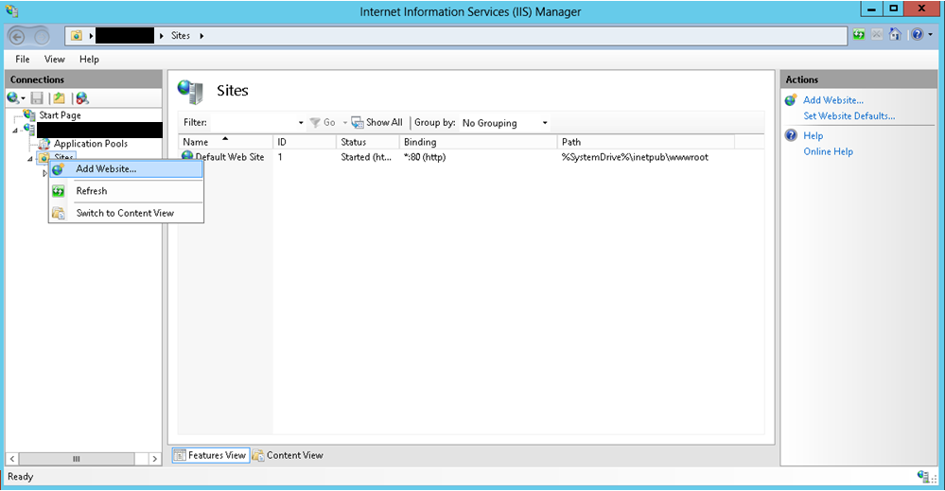
  5. Site name: Perceptive Reach – Physical path: “C:/PerceptiveReach/Dashboard/” – Host name: <official domain name> 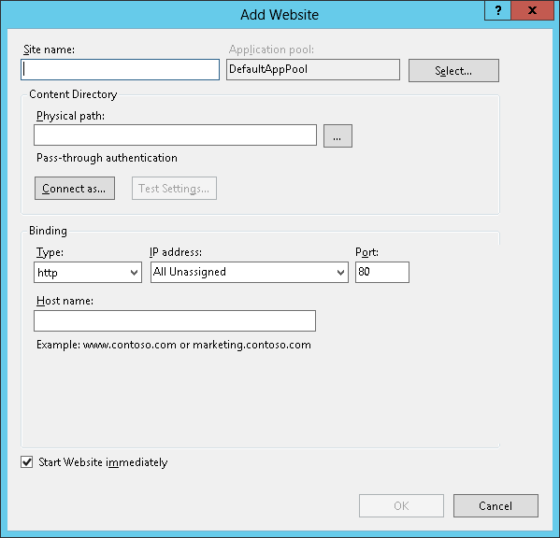
  6. Follow the steps to change the Application Pool to a custom Application Pool. To do those follow the below steps:
     + In the advanced setting window for the Application Pool (ApplicationPoolIdentity), Click on Identity row and select the ellipsis (…) displayed at the right end of the row to open “Identity” window.

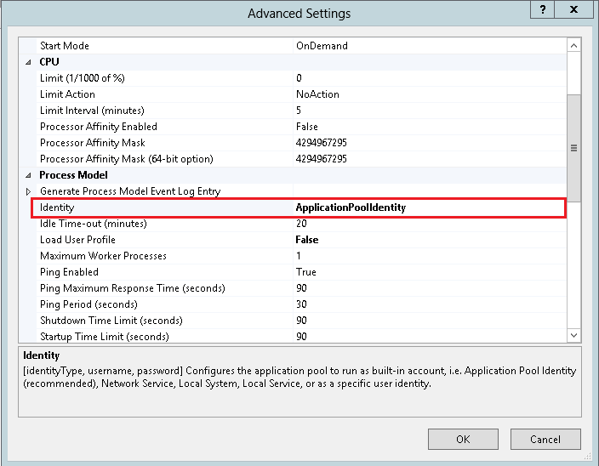

* + Select Custom account and click on “Set” button.

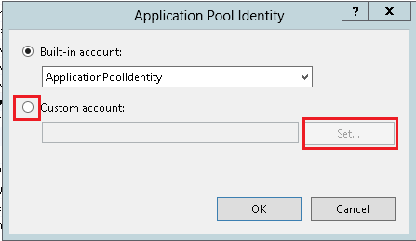

* + In the “Set Credentials” window, Type the User Name(PRAppPool), Password and Confirm Password details. Ensure the user name has admin rights to the server.
* Click OK and close all other widows by clicking OK on each of the open windows. Ensure the new identity is reflected in the app pool list (PRAppPool)

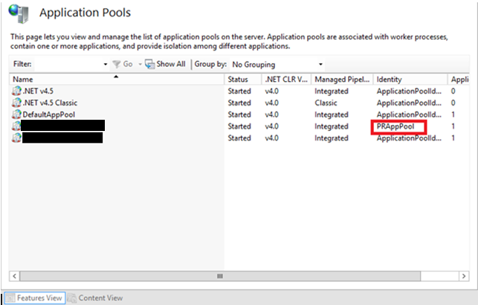

* 1. Verify that the check box for “Start Website immediately” is selected prior to clicking “OK”
  2. Using the “Add Website” function accessed by right clicking on “Sites” – Proceed to create the Perceptive Reach Direct site
  3. Site name: Perceptive Reach Direct – Physical path: “C:/PerceptiveReach/Direct/” – Host name: <official domain name>

# Post-Installation

Please refer to the Perceptive Reach System Administrator Guide for additional post-install actions related to administrative tasks including: backup, monitoring, and tuning.

## Technical Tests

Upon complete of the installation and configuration of the database and application the System Administrator can perform the following tests.

1. Create a test user using a system admin account (See System Admin Guide for User Creation)
   1. Open Internet Explorer and navigate to the URL, Login into the application with the created sys admin account and validate that the Perceptive Reach test data displays. If any errors occur or the Webpage is not accessible please review the installation steps and System Administration Guide.
2. Launch R via the Desktop Shortcut. If any errors occur during application launch please review the installation steps and System Administration Guide.
3. Launch BIRT via the Desktop Shortcut. If any errors occur during application launch please review the installation steps and System Administration Guide.

# Uninstall

The process of uninstallation represents a complete removal of application and installation files. The administrator is recommended to stop the application and database respectfully utilize IIS Management and SSMS. Once the application has been stopped the components and software can be uninstalled utilizing the Windows Uninstall Programs function and Windows File Manager for deletion. It is also recommended that all compiled code and IIS configurations are removed to facilitate a complete removal of the software, application, and database.

# Acronyms

Table : Acronyms and Definitions

| Term | Definition |
| --- | --- |
| BIRT | Business Intelligence Reporting Tool |
| IDE | Integrated Development Environment |
| IIS | Internet Information Services |
| IOC | Initial Operating Capability |
| IRDS | Integrated Reach Database System |
| ISO | Information Security Officer |
| JDBC | Java Database Connectivity |
| PR | Perceptive Reach |
| SME | Subject Matter Expert |
| SSMS | SQL Server Management Studio |
| TRM | Technical Reference Model |
| VA | Department of Veterans Affairs |
| URL | Uniform Resource Locator |
| VHA | Veterans Health Administration |